“[Click Here to enter Title]”



[##-arid-####]

Please Select Department [Empty for Institute]
please select Faculty / Institute
PIR MEHR ALI SHAH
ARID AGRICULTURE UNIVERSITY RAWALPINDI
PAKISTAN

“[Click Here to enter Title]”

by

[Your full name]
[##-arid-####]

A thesis submitted in partial fulfillment of
the requirement for degree of

MSc.(Hons.)
in
Agronomy

Please Select Department [Empty for Institute]
please select Faculty / Institute
PIR MEHR ALI SHAH
ARID AGRICULTURE UNIVERSITY RAWALPINDI
PAKISTAN

CERTIFICATION
I hereby undertake that this research is an original one and no part of this thesis falls under plagiarism, If found otherwise at any stage, I will be responsible for the consequences.
Name: [Your full name] Signature: ______________
Registration Number: Date: ______________

Certified that the contents and form of thesis entitled “[Click here to Enter Title]” submitted by “[Your full name]” has been found satisfactory for requirements of the degree.

Supervisor: ____________________
(Name)

Co-Supervisor: __________________
(Name)

Member: _________________________
(Name)

Member: _______________________

Date of Viva Voce: _______________ External Examiner: _______________
(Name)

Chairperson: _________________________

Director Advanced Studies: ___________________________
DEDICATION
Text Here

CONTENTS
Page
List of Tables ix
List of Figures x
Acknowledgements xi
Chapter 1 Introduction 1
1.1 Heading 1 1
1.1.1 Subsection Title 1
1.1.1.1 Heading title 3 2
Chapter 2 Chapter Title 4
2.1 Section Title 4
2.1.1 Subsection Title 4
2.1.1.1 Subsection title 4

Abbreviations
Text Here

List of Tables
Click on the bold text below. Right click mouse button and select “Update Field” to display the current list of tables in the document. Delete this help text when no longer required.
Table ‎1.1: Insert Table Caption using “Table Caption” Command in ARID Thesis Toolbar 3

List of Figures

Click on the bold text below. Right click mouse button and select “Update Field” to display the current list of figures in the document. Delete this help text when no longer required.
Figure ‎1.1: Insert figure caption using “Figure Caption” command in ARID Thesis Toolbar 2

Acknowledgements

Text Here.

Introduction

Insert additional chapters with the “New Chapter” command on the menu bar or under “ARID Thesis Tools”.

Heading 1
Welcome to PMAS-Arid Agriculture University, Rawalpindi. The approved reference style is American Psychological Association (APA) 6th edition. APA requires that information be cited in 2 different ways citation in the text and in a reference list at the end of the paper. Citation of one reference with one author within or at the end of sentence is like this (Ramsin, 2010). Start of Sentence is like this. Ramsin (2010) has presented this study. One reference by two authors: Within or End of Sentence: In this study the authors (Pereira & Fontoura, 2012) has reported. Start of Sentence is like this. Pereira & Fontoura (2012) has presented this study. One reference by three to five authors is like this (Healy, Matthews, Dunstan, Winkler, & Owen, 2011). Start of the Sentence: Healy et al. (2011) has presented this study. One reference by six or more authors is like this (Ashburner et al., 2000). Start of the Sentence: Ashburner et al. (2000) has presented this study.Multiple references is like this. All citation: In these studies the authors (Ashburner et al., 2000; Pereira & Fontoura, 2012; Ramsin, 2010) have presented. All Citation: In this study the author All Citation: In this study the author Being an Agricultural Institution, our main objective is to produce high quality Agricultural Scientists. Therefore, we are committed with the philosophy that we advance our farmer community by sharing positive and proven ideas and experiences. Along with Agricultural Sciences, the university offers degree programs at all levels in basic and Natural Sciences, Social Sciences, Humanities, Management Sciences, Computer Sciences and Information Technology.
With a dynamic and stimulating educational environment, our tradition is to accept challenges and to receive wisdom today, in order to achieve new things and new approaches for tomorrow. Embracing education in its widest context, we continually strive to remain at the forefront of knowledge.

Subsection Title
With a dynamic and stimulating educational environment, our tradition is to accept challenges and to receive wisdom today, in order to achieve new things and new approaches for tomorrow. Embracing education in its widest context, we continually strive to remain at the forefront of knowledge. Embracing education in its widest context, we continually strive to remain at the forefront of knowledge. Embracing education in its widest context, we continually strive to remain at the forefront of knowledge.

Heading title 3
Insert section using “Start New sub-subsection” command form “ARID Thesis Tools”.
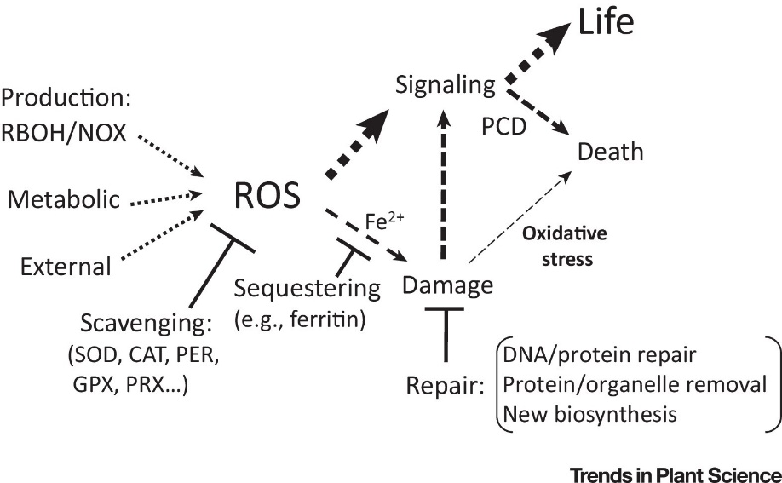
Figure 1.1: Insert figure caption using “Figure Caption” command in ARID Thesis Toolbar
Figure 1.1 shows a representation of our proposed model. All Capitalized Letters. Welcome to PMAS-Arid Agriculture University, Rawalpindi. Being an Agricultural Institution, our main objective is to produce high quality Agricultural Scientists. Therefore, we are committed with the philosophy that we advance our farmer community by sharing positive and proven ideas and experiences. Along with Agricultural Sciences, the university offers degree programs at all levels in basic and Natural Sciences, Social Sciences, Humanities, Management Sciences, Computer Sciences and Information Technology.
With a dynamic and stimulating educational environment, our tradition is to accept challenges and to receive wisdom today, in order to achieve new things and new approaches for tomorrow. Embracing education in its widest context, we continually strive to remain at the forefront of knowledge.

Table 1.1: Insert Table Caption using “Table Caption” Command in ARID Thesis Toolbar
Parameter 1 | Parameter 2 | Parameter 3 | Parameter 4
1 | Aaa | Bbb | Ccc
2 | Ddd | Eee | Fff
3 | Ggg | Hhh | eee
As shown in Table 1.1, with a dynamic and stimulating educational environment, our tradition is to accept challenges and to receive wisdom today, in order to achieve new things and new approaches for tomorrow.

Chapter Title

Section Title

Summary

Literature cited
Ashburner, M., Ball, C. A., Blake, J. A., Botstein, D., Butler, H., Cherry, J. M., … others. (2000). Gene Ontology: tool for the unification of biology. Nature Genetics, 25(1), 25–29.
Healy, G. N., Matthews, C. E., Dunstan, D. W., Winkler, E. A. H., & Owen, N. (2011). Sedentary time and cardio-metabolic biomarkers in US adults: NHANES 2003-06. European Heart Journal, 32(5), 590–597. https://doi.org/10.1093/eurheartj/ehq451
Pereira, G. V., & Fontoura, L. M. (2012). Defining Agile and Planned Method Fragments for Situational Method Engineering. VIII Simp{ó}sio Brasileiro de Sistemas de Informa{ç}{ã}o. Fortaleza, Brasil.
Ramsin, R. (2010). Towards tool support for situational engineering of agile methodologies. In Software Engineering Conference (APSEC), 2010 17th Asia Pacific (pp. 326–335).

